PLEASE JOIN US!
Meet & Support Our Seminarians

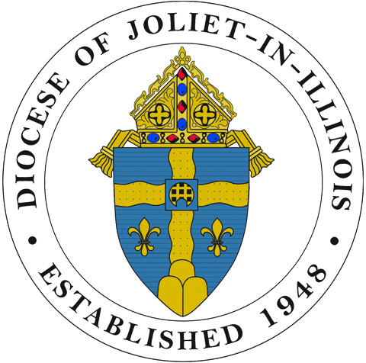Diocese of Joliet
42nd Annual Seminarian Sendoff
“Celebrating the Future of Priesthood”

Sunday, August 7, 2016
1:30 to 4:30 pm
Krasa Center, Benedictine University, Lisle
_________________________

Come to the Seminarian Sendoff
Adults: $25 Children 5–12: $15
Children under 5: Free
Visit and dine with our seminarians and their families.
Join Bishop R. Daniel Conlon in showing your support.

Be a “Champion for Vocations”
A donation helps make the Sendoff possible and proceeds are shared with the diocesan Vocation Office.
We Are Called: $25-$99 Deacon: $500-$999
Candidate: $100-$249 Priest: $1000-$2000
Seminarian: $250-$499 Bishop: $2500
“Champions” are recognized in the Sendoff Program Book.

Please respond by July 22, 2016.

To make a reservation or a donation
Contact George at
serraclubdc.outlook.com or 630-917-7580
_________________________________________
Serra Club of DuPage County
Founder and Sponsor of the Seminarian Sendoff

Proceeds from the Sendoff go to the diocesan Vocation Office
to support the education of our seminarians.

