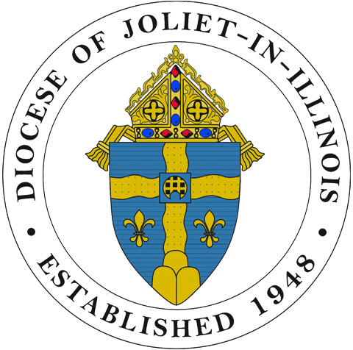 2017 SEMINARIAN CARDS 2018 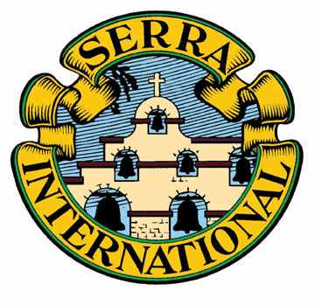
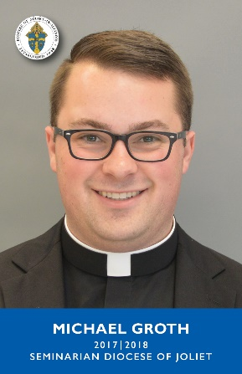

Reminder to … Pray for our seminarians and all vocations.
Create awareness … National Vocation Awareness Week (Nov. 5 -11, 2017).
Use to … Stimulate vocation discussion in classes and groups.

ORDERING INFORMATION
[Cards are 2.75” x 3.75” in full color.]
Please allow 10 days for shipping.

43 cards (one of each seminarian) ………………. $8.00/deck ____ deck(s) $_________
25 cards __________________________ $6.00/pack ____ pack(s) $_________
Seminarian Name
TOTAL $__________
(Shipping included)

Additional cards in Spanish are available of our ten Spanish-speaking seminarians: Alvarez, Corona,
Flores, Fonseca, Garcia, Oliveros, Padilla, Sanchez, Sarabia and Sida. Please inquire.

- Direct questions & orders to: serraclubdc@outlook.com, 630-917-7580 or
Serra Club, attn. G. Carr – 320 Browning Court – Wheaton, IL 60189
- Make payment to: Serra Club of DuPage County. (Mail to address above)
- An invoice will be sent with order if payment is not received in advance.

NAME________________________ ORGANIZATION_________________________________
ADDRESS______________________________ CITY______________________ ZIP__________
EMAIL_________________________________________ PHONE________________________
The Seminarian Cards are produced and distributed by the Serra Club of DuPage County.
www.serradupage.org

