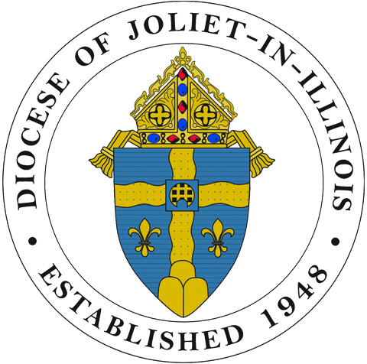Diocese of Joliet
43rd Annual Seminarian Sendoff
Celebrating the Future of Priesthood
Sunday, August 6, 2017
1:30 to 4:30 pm
Krasa Center, Benedictine University, Lisle

Meet the nearly 45 seminarians and their families and show your support for them
by your attendance and/or a donation that helps make the Sendoff possible.”
RESERVATIONS
Join our bishops and priests in celebrating our seminarians at a dinner and program.
Adults: $30 Children 5-12: $15 Children under 5: No Charge

CHAMPION FOR VOCATIONS
“Champion” donations are recognized in the program book and excess funds are shared
with the diocesan Vocation Office for the formation of the seminarians.
We Are Called: $25-$99 Candidate: $100-$249 Seminarian: $250-$499
Deacon: $500-$999 Priest: $1000-$2000 Bishop: $2500

Reservations and/or Donations: Contact George at
serraclubdc@outlook.com or 630-917-7580

Serra Club of DuPage County is the founder and sponsor of the Seminarian Sendoff.

