VianneyMedia
from “Vianney News”, Spring 2014 (Newsletter of St. John Vianney College Seminary, St. Paul, MN

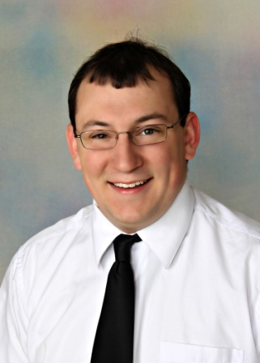
Joliet seminarian Ryan Adorjan arrived at SJV in 2011 with an interest in promoting Pope Benedict XVI’s call for a New Evangelization through social media. “You have to go where the people are,” he said. “Today, they are online. That is where the young people will be exposed to the Church and the mysteries of God.”

Adorjan started compiling an online photo gallery for the seminary and helped SJV staff and seminarians with a variety of computer issues. Word spread quickly and he became the “go to” guy for all things media around the seminary. Adorjan recalls the irony of him taking on this role because, growing up, his brother was the “computer guy.” However, Ryan was no stranger to working with media as he successfully helped redesign and co-produce his high school’s television station before graduation.

In 2012, Adorjan approached Fr. Becker about creating a team that would manage the SJV Facebook page, take photos at events, and record homilies and seminarian testimonials. Fr. Becker approved and VianneyMedia has been going strong ever since.

VianneyMedia now consists of four seminarians who share the duties of updating and maintaining the website, Facebook page and YouTube channel; videotaping homilies and lectures by Fr. Becker, visiting priests and guests; recording seminarian’s “Priest Hero” talks; and creating electronic billboards to advertise SJV events on the UST campus. If that is not enough to keep the team busy, they also assist with basic troubleshooting around the seminary and serve as a liaison between SJV and the university’s Information & Resource Technology Department and Web and Media Services.

Adorjan and his VianneyMedia team believe using technology and social media is an effective way to share what the future of the priesthood looks like. Another bonus is that parents and benefactors can see what life is like inside the seminary as well.

After graduation in May, Adorjan will leave SJV and VianneyMedia for Mundelein Seminary in Illinois. No doubt he will be able to share, like and tweet the good news from the major seminary, too.

“VianneyMedia has the potential to move hearts, inspire vocations, and proclaim the great works of God, far and wide.” Fr. Michael C. Becker, Rector

