PICTURE YOURSELF AS A PRIEST
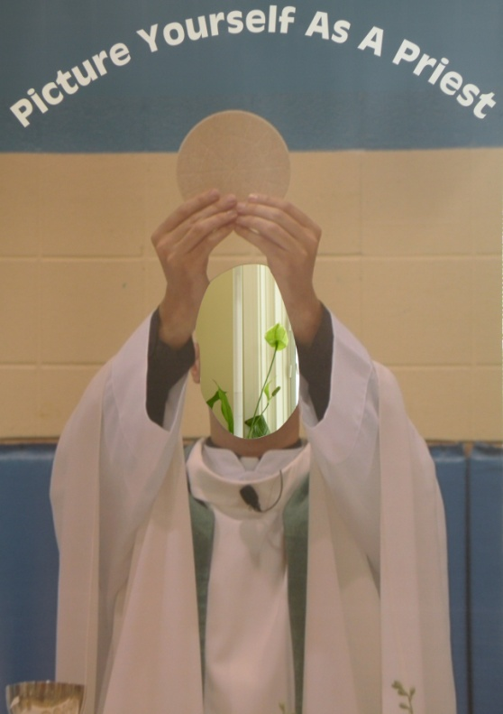
3'x6' Free-Standing Priest Poster: easy to assemble & durable
(with face cutout for picture taking)

“Ideal vocation tool for schools and religious education programs.”
“Works well with Vacation Bible Schools.”
“Can be used in the narthex before and after Sunday Masses.”
“Great for parish picnics & other parish ocassions.”
___________________See reverse side for information on how to order & use the “Priest”______________________
RESERVE THE POSTER TODAY!

Rental: $25.00 shipping & handling + return shipping.
(Can be picked up and returned if more convenient.)

Contact George Carr: 630-917-7580 or serraclubdc@outlook.com

Serra Club of DuPage County
Encouraging and affirming vocations to the priesthood and
vowed religious life through prayer and active fellowship since 1958.
WWW.SERRADUPAGE.ORG

Picture Yourself as a Priest
SOME “HOW TO” IDEAS
- Plan ahead! Reserve the “POSTER” early!
- Identify an occasion or event and promote “Picture Yourself as a Priest.”
- Provide a small step ladder for younger children.
- Select a location with good lighting.
- Give away prayer cards to all who have their pictures taken.
- Have vocation information materials available.
- Have enough volunteers (2-3) to keep things organized.
- DON’T ALLOW IT TO TURN INTO A JOKE! SMILES ARE GOOD!

Picture Taking

- Encourage people to bring their own cameras or share with a friend.
- Suggest they frame their picture tightly to the poster.
- Have the person put their head into the cutout opening.
- If you provide the camera, be prepared to record the names and contact information and be able to coordinate the names with the pictures on the memory card or film.

Ordering Information

- Reservations: George Carr, 630-917-7580 or serraclubdc@outlookcom
- Make checks payable to: SERRA CLUB of DuPage County.
Mail to: George Carr, 320 Browning Ct., Wheaton, IL 60189
- The “Priest” can be picked up and/or delivered if you are located conveniently to Wheaton. (The $25 shipping and handling charge will still apply.)
- If the “Priest is returned by parcel post, UPS, etc., it must be insured for $250.
- Plan to return the “Poster” immediately after your event.

Serra Club of DuPage County
Encouraging and affirming vocations to the priesthood and
vowed religious life through prayer and active fellowship since 1958.

WWW.SERRDUPAGE.ORG

