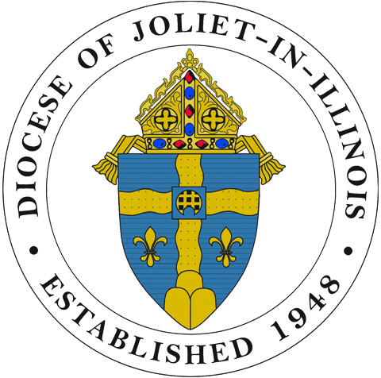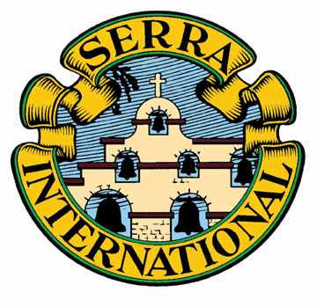

2014 Diocese of Joliet 2015
Remember and pray for our seminarians!

New Design and New Program
- A new design features a brief reflection by each man and a larger photo.
You will want to read each man’s reflection. They are varied, interesting and inspirational.
- Complimentary* cards will be distributed to all 6th through 8th grade students attending Catholic Schools and Religious Education programs.

ORDER NOW – Available October 24, 2014
Pass out at Masses, i.e. National Vocation Awareness Week.
Use as bookmarks, prayer reminders, gifts…
Promote vocations in parishes and schools.

ORDERING INFORMATION (See Sample Card on Back)
PRICES (Shipping costs included)
$5.00 per ASSORTMENT (36 cards: one of each seminarian)
$4.00 per PACK (25 cards of one seminarian)
*Spanish language cards for seminarians: Alfaro, Hernandez, Oliveros, Padilla, Sarabia, Sida & Torres
$5.00 per ASSORTMENT (35 cards: 5 each of the seven Spanish speaking seminarians)
$4.00 per PACK (25 cards of one Spanish speaking seminarian)
ORDERS or Questions
Email: serraclubdc@outlook.com or mail to address below.
Provide your name, address, phone number and quantities. Specify the seminarian’s name for PACKS.
PAYMENT
Make checks payable to: Serra Club of DuPage County
Mail to: Serra Club, attn: G. Carr - 320 Browning Ct. - Wheaton, IL 60189

*The Serra Club will accept donations to help offset the cost of supplying the complimentary cards to the Catholic Schools and Religious Education programs.

The Seminarian Cards are produced and distributed by the Serra Club of DuPage County assisted by the Vocation Office, DoJ.

SAMPLE
SEMINARIAN CARDS 2014 – 2015
Actual Size: 4” x 3”

FRONT BACK

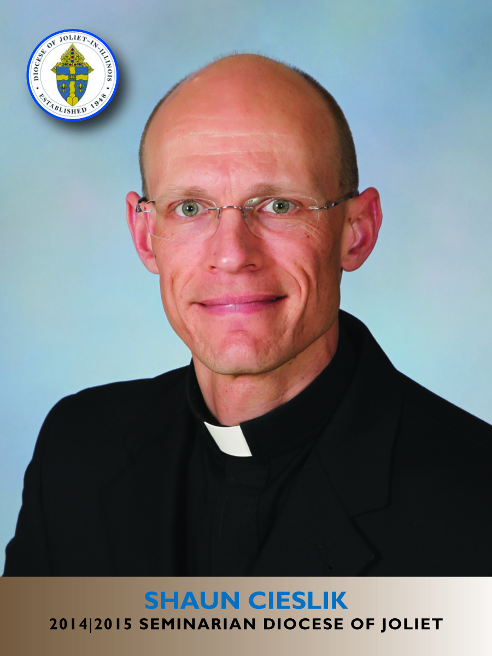

Card Specifications
Full Color
4” x 3”
Coated Card Stock

